MRGYM – Technical Report
Martim Alves (1240690), Ricardo Monteiro (1240842)

Abstract. This report serves as a guide to understanding the work put into the development of the application MRGym. All work processes will be shown throughout the document with diagrams, code, tests, and reasoning of the choices we made.
Keywords: a
1 Introduction
In the context of the project proposed in the curricular unity of Developing Software and Mobile Systems (DSSMV), we proposed the idea of a gym app, with the means to solve the problem of a trainer not having a source of information for how an exercise is done, and what part it trains.
With the main objective of the project being communication with the world, that through a rest API, we decided to use two APIs, those being Restdb, and Wger. Restdb serves as a database, where the app will store data (eg. Users; workouts; photos), and Wger allows the application to get a variety of Gym exercises, their images, and save workouts. The app also requires the use of android hardware, and for that we decided to use the camera, for tracking progress.
The app helps the user with tracking the progress of their workouts, which they can create and customize with different exercises, with different weights, repetitions, and sets. MRGym also serves as a helper for the user to see their progress throughout their fitness journey with a journal, where they can post photos of themselves, and note their weight at the time.
With the intuition of having different users and keeping information private for each user, there is a register and login system in the system, which saves and coordinates every saved aspect to the correct account. We felt the need to add this system to come closer to what would be a real utilization of the app, where different people would install and use it.
The development of our work has been documented in UML, to help with the understanding of our though process and how the program works. That means diagrams like domain model, class diagram, use cases, SSDs, SDs, and other diagrams will appear throughout the document.
2 Analysis
To understand and solve the problem, first we analyzed how we should build the app. That implies a set of use cases, functional and non-functional requirements, as well as the domain model, a class diagram, a glossary, sequence diagrams, system sequence diagrams, and more.
2.1 Domain Model
The Domain Model represents the main elements of the system graphically, as well as their relationship. To further understand how each element interacts with each other, we first defined the entities and their relationship, allowing a good foundation for the rest of the modeling of the app.
Our domain model, presented in Figure 1, consists of 5 main entities, those being User, WorkoutLog, JournalEntry, WorkoutPlan and Exercise. A user can create any number of workout plans, and those workout plans contain at least one exercise. The user also records up to any number of journal entries.

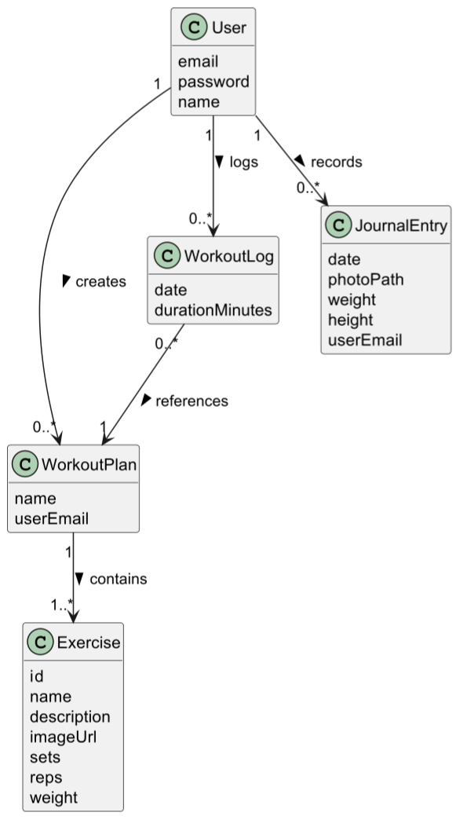
Figure 1
2.2 Glossary
The glossary defines the elements, so that there is a clear understanding of what each element means and represents. Our glossary is demonstrated in Table 1.

Table 1
Technical Term | Definition
Exercise | Planned, structured, and repetitive physical activity designed to improve and maintain physical fitness.
JournalEntry | A photo with details of how much a user weights and how tall a user is.
User | Person who interacts with the app, to track their progress.
Workout Log | Date and duration of a workout.
Workout Plan | Structured personalization of a set of different exercises.

2.3 Requirements
Use cases (UCs) define the functionalities that the user will be able to use during the utilization of the app. In Figure 2 we present our use case diagram, consisting of 11 different use cases, meaning the user will have a variety of options to choose from in our app.

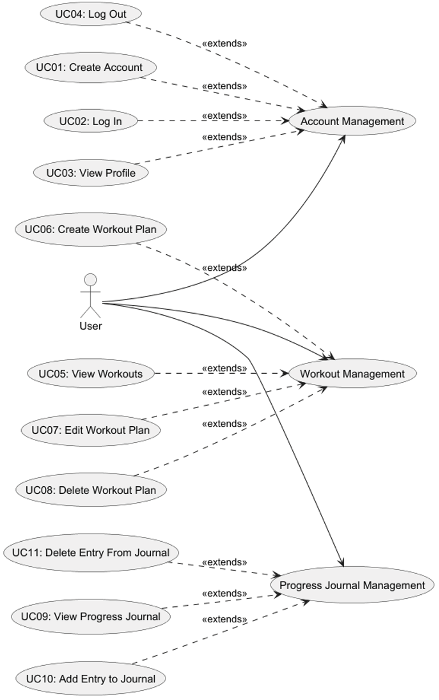
Figure 2
After defining the requirements, the next step is to draw the SSDs (System Sequence Diagrams). These diagrams are a general representation of a functionality, meaning there isn’t really any code involved in it yet, but it helps with understanding the system logic, and later build the system diagrams, which will be more precise.

SDD – UC1: Create Account

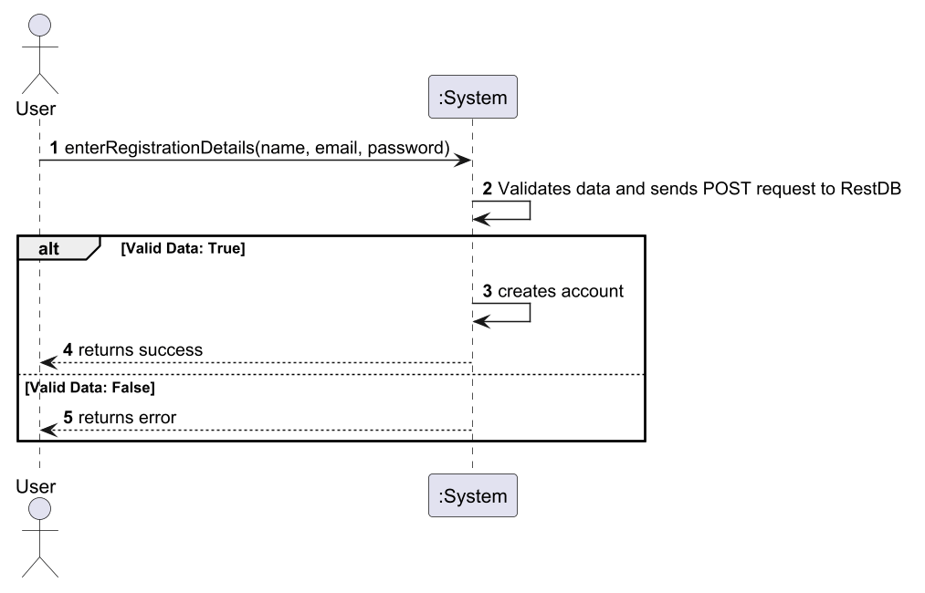
Figure 3

SDD – UC2: Log In

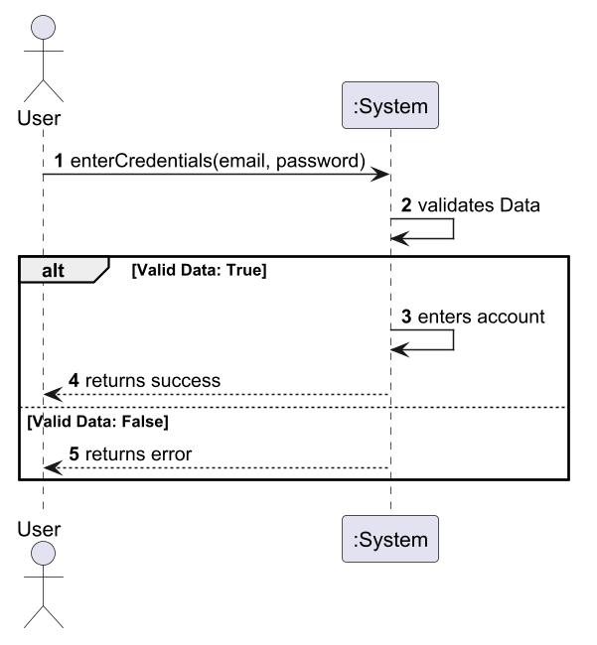
Figure 4

SDD – UC3: View Profile

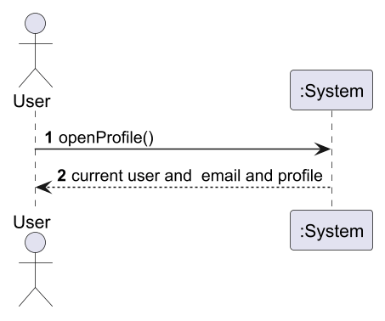
Figure 5

SDD – UC4: Log Out

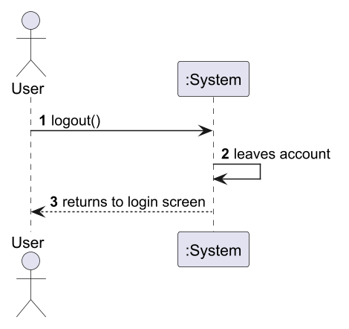
Figure 6

SDD – UC5: View Workouts

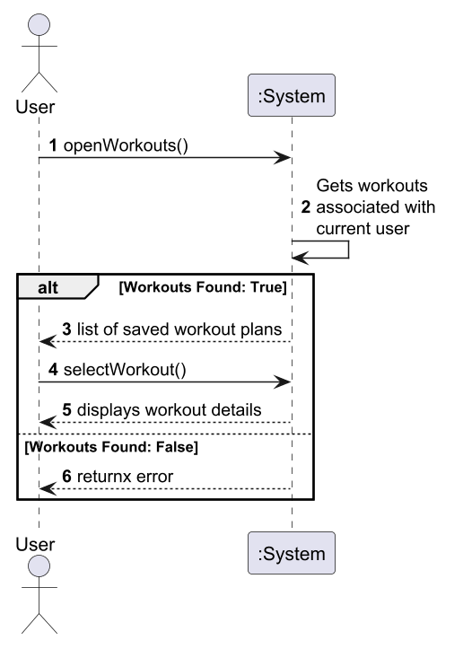
Figure 7

SDD – UC6: Create Workout Plan

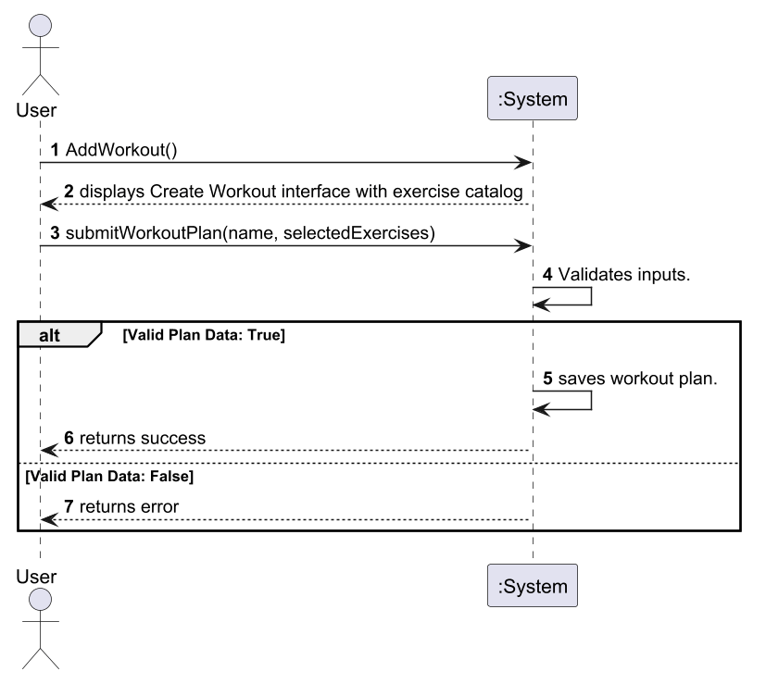
Figure 8

SDD – UC7: Edit Workout Plan

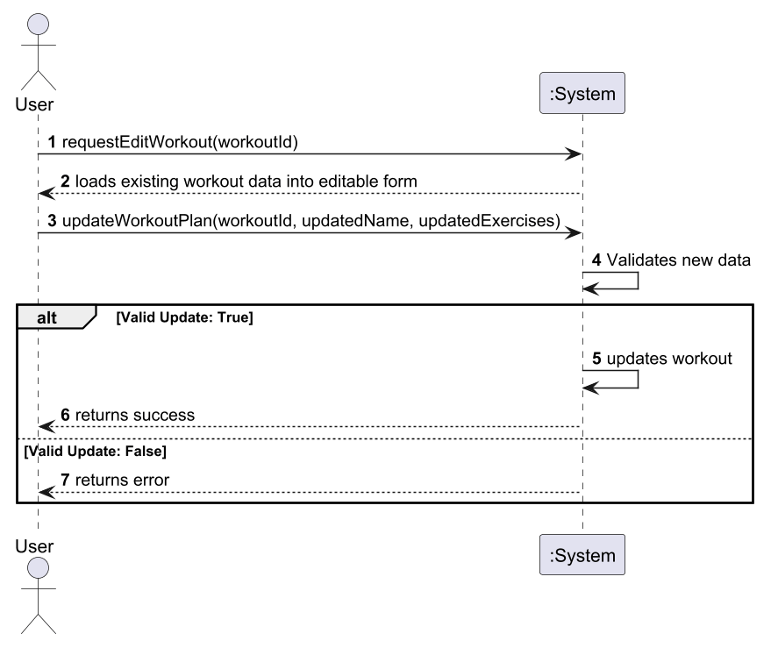
Figure 9

SDD – UC8: Delete Workout Plan
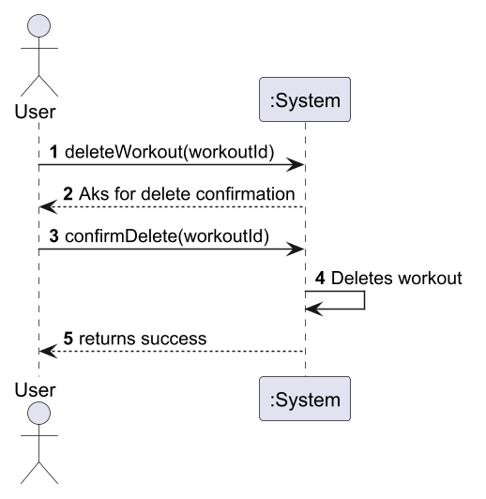
Figure 10

SDD – UC9: View Progress Journal

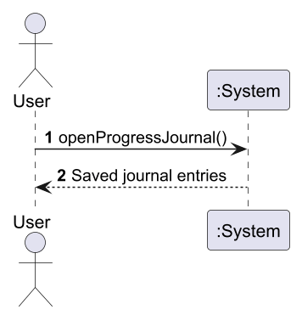
Figure 11

SDD – UC10: Add Entry to Journal

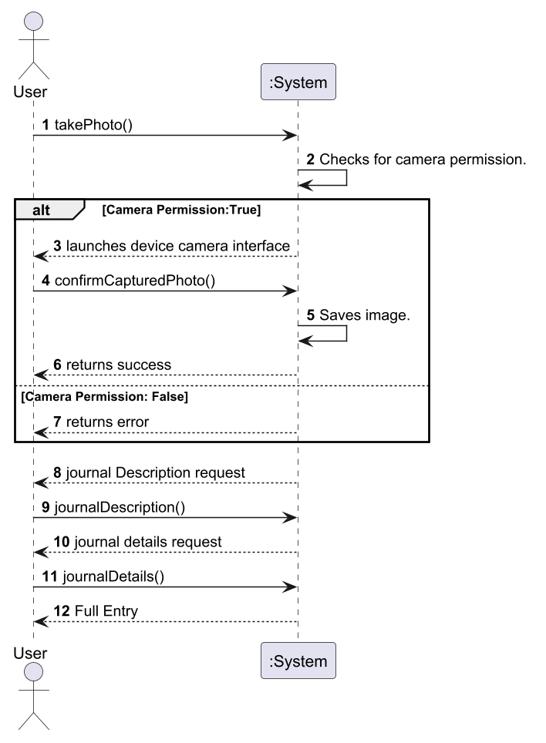
Figure 12

SDD – UC11: Delete Entry from Journal

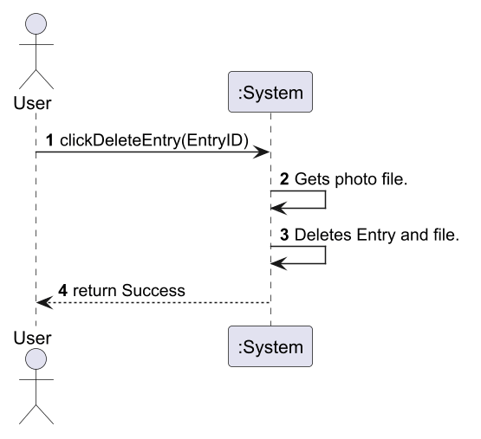
Figure 13

After drawing the SSDs, our next step was to build the SD’s, which as referenced before, are a more detailed and complexed view of how the code will function and classes will interact.

SD – UC1: Create Account

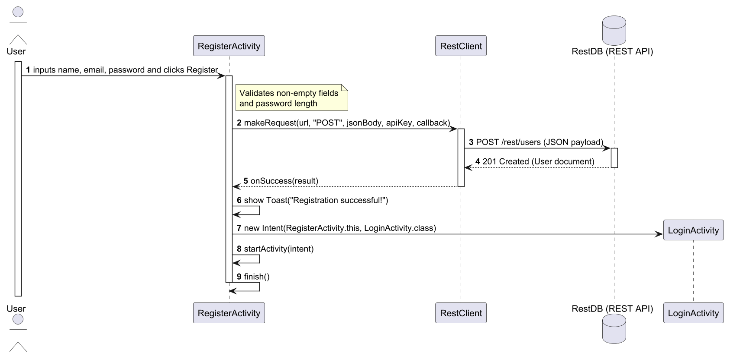
Figure 14

SD – UC2: Log In

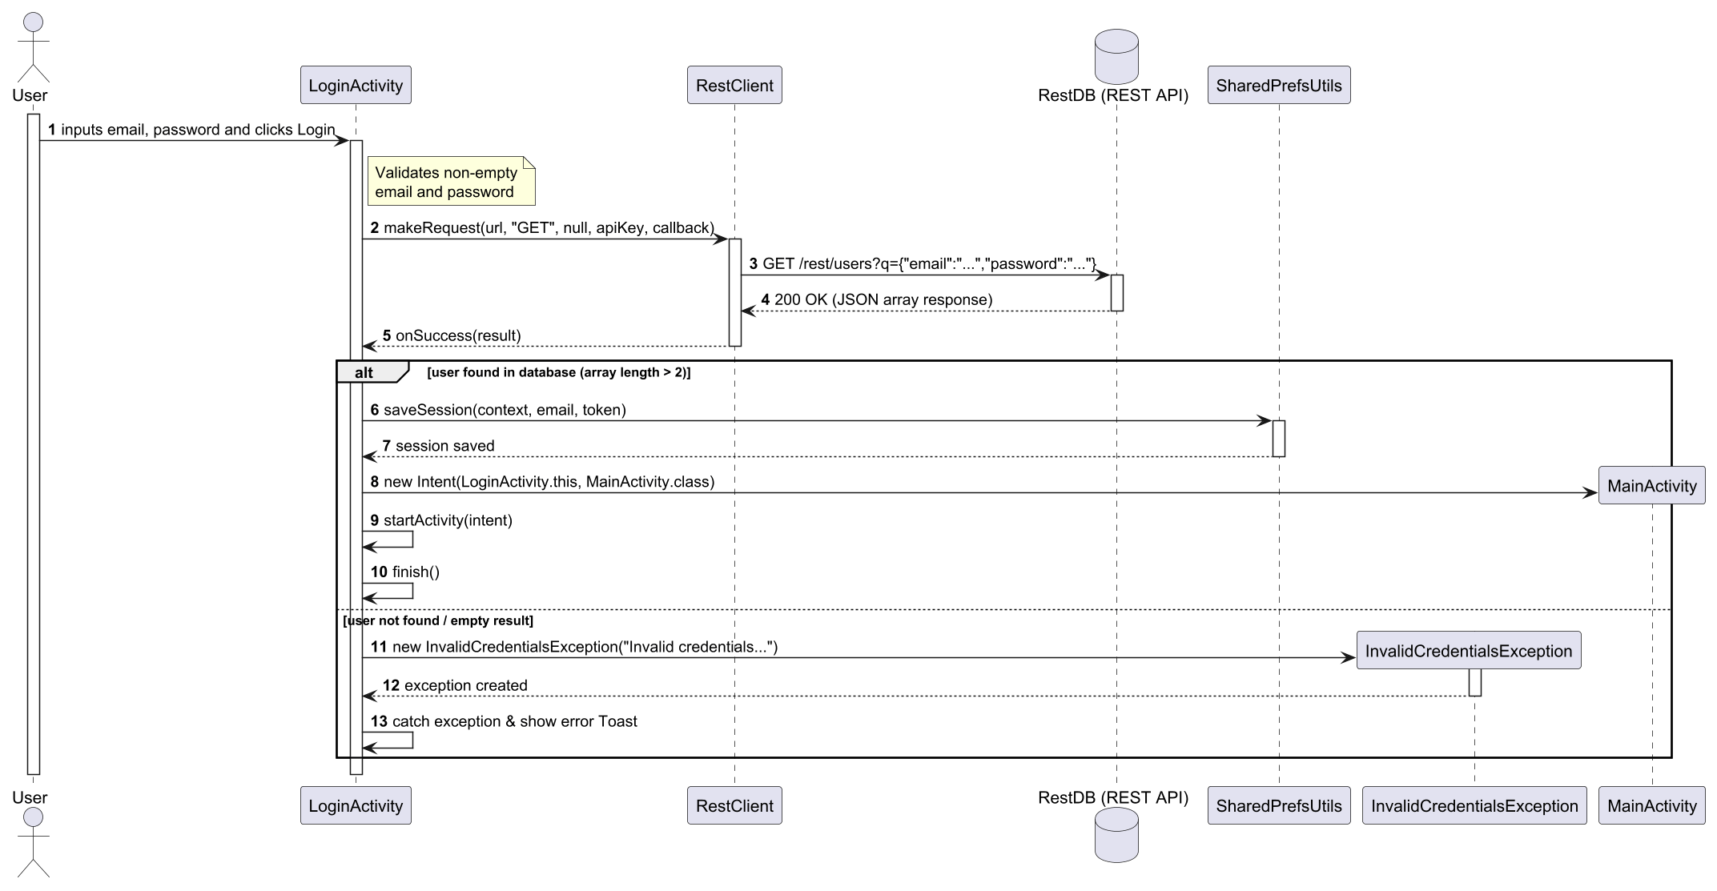
Figure 15

SD – UC3: View Profile

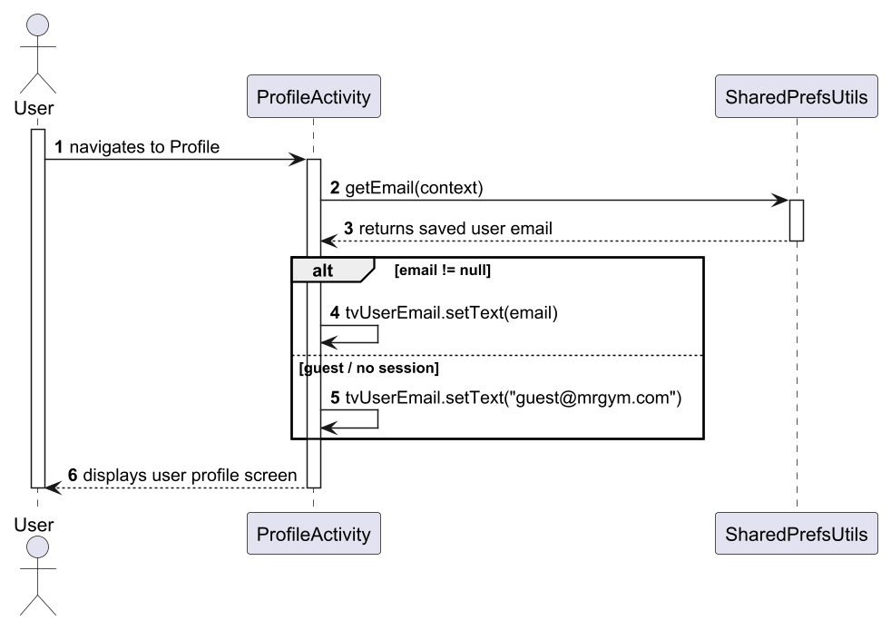
Figure 16

SD – UC4: Log Out

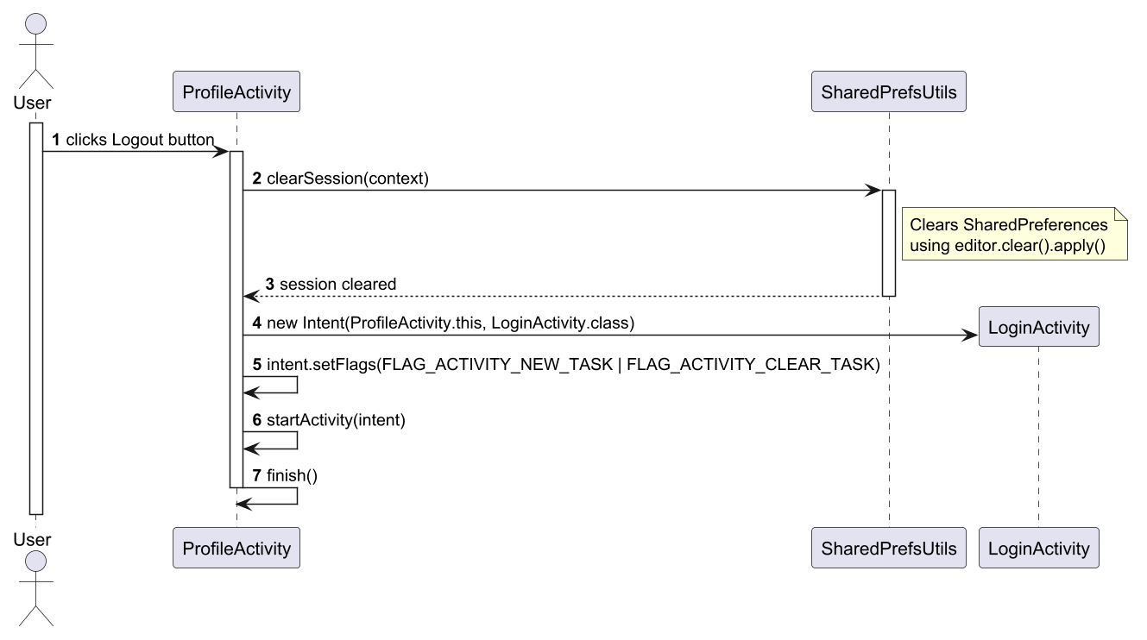
Figure 17

SD – UC5: View Workouts

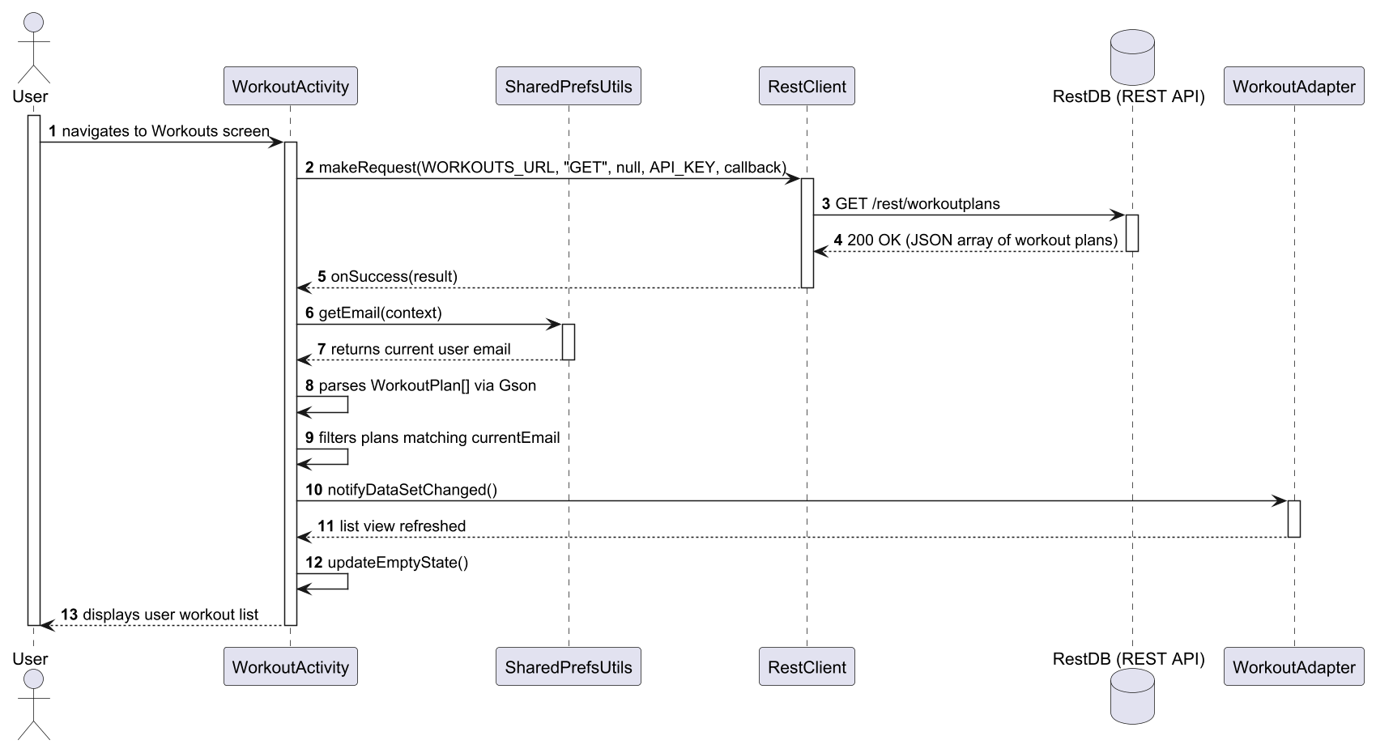
Figure 18

SD – UC6: Create Workout Plan

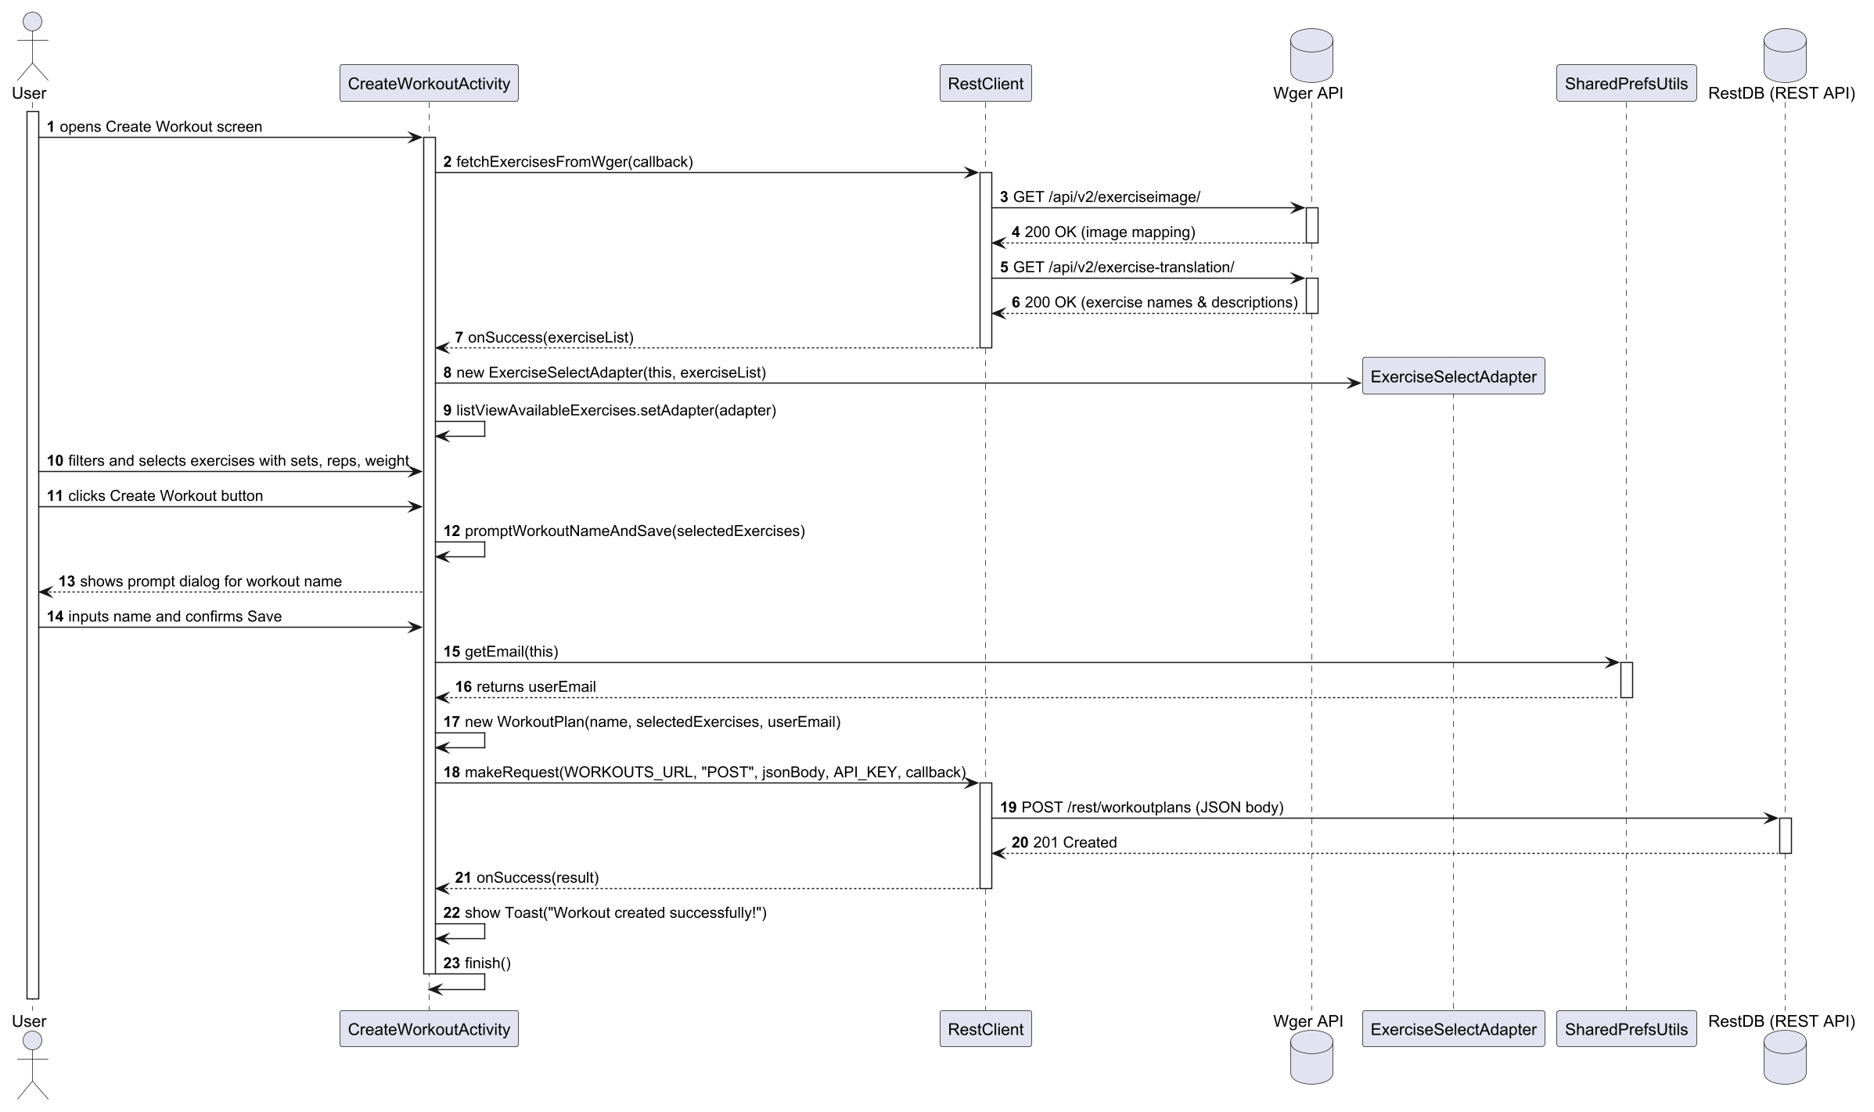
Figure 19

SD – UC7: Edit Workout Plan

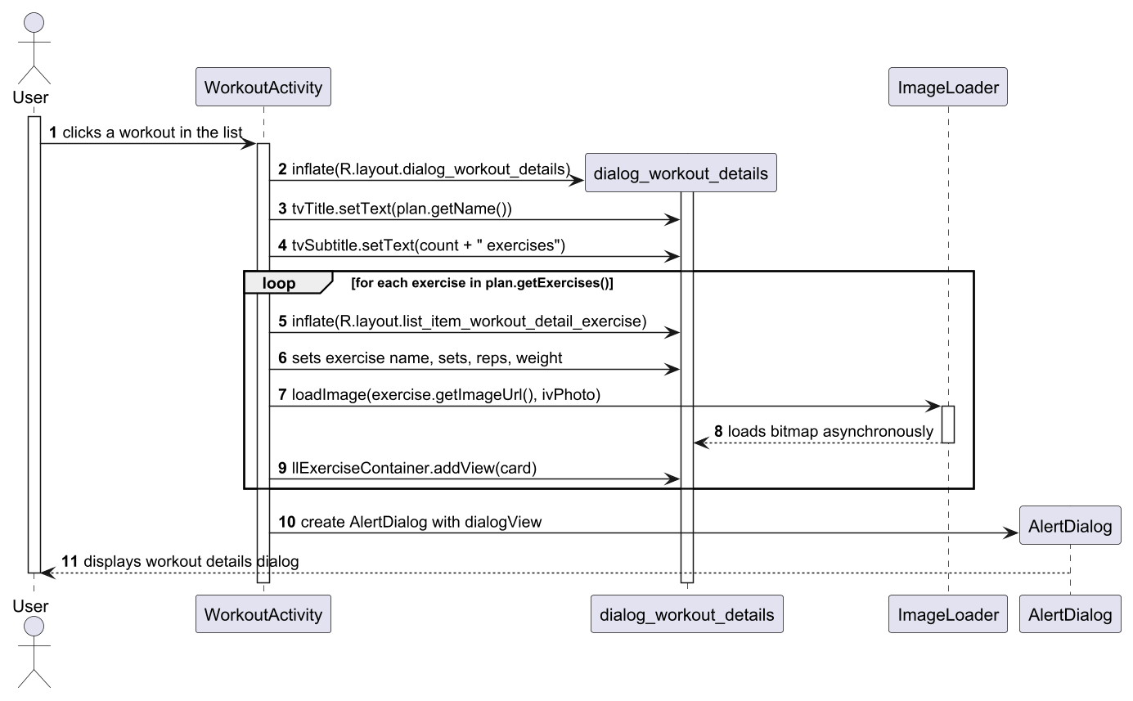
Figure 20

SD – UC8: Delete Workout Plan

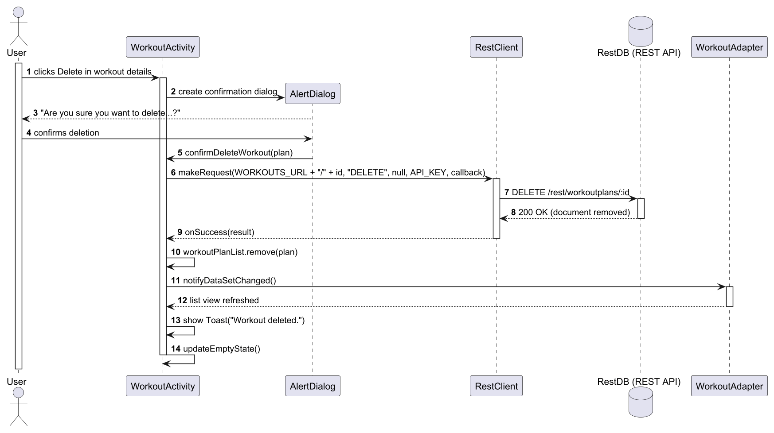
Figure 21

SD – UC9: View Progress Journal

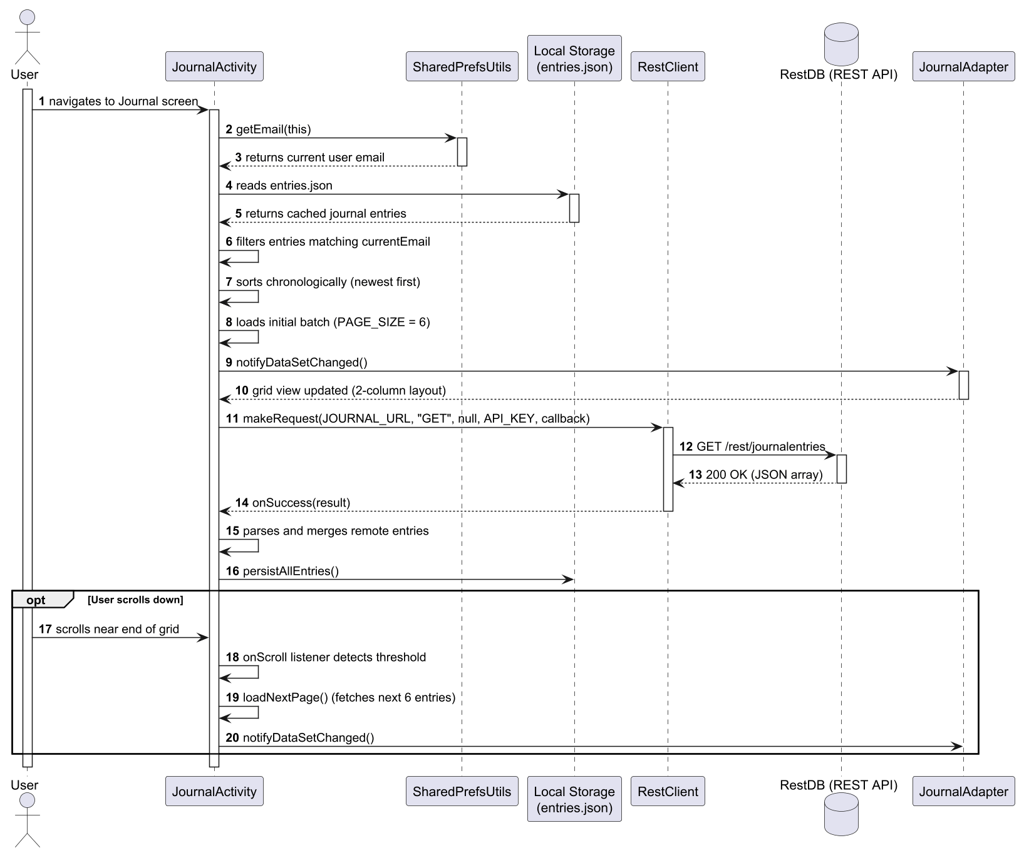
Figure 22

SD – UC10: Add Entry to Journal

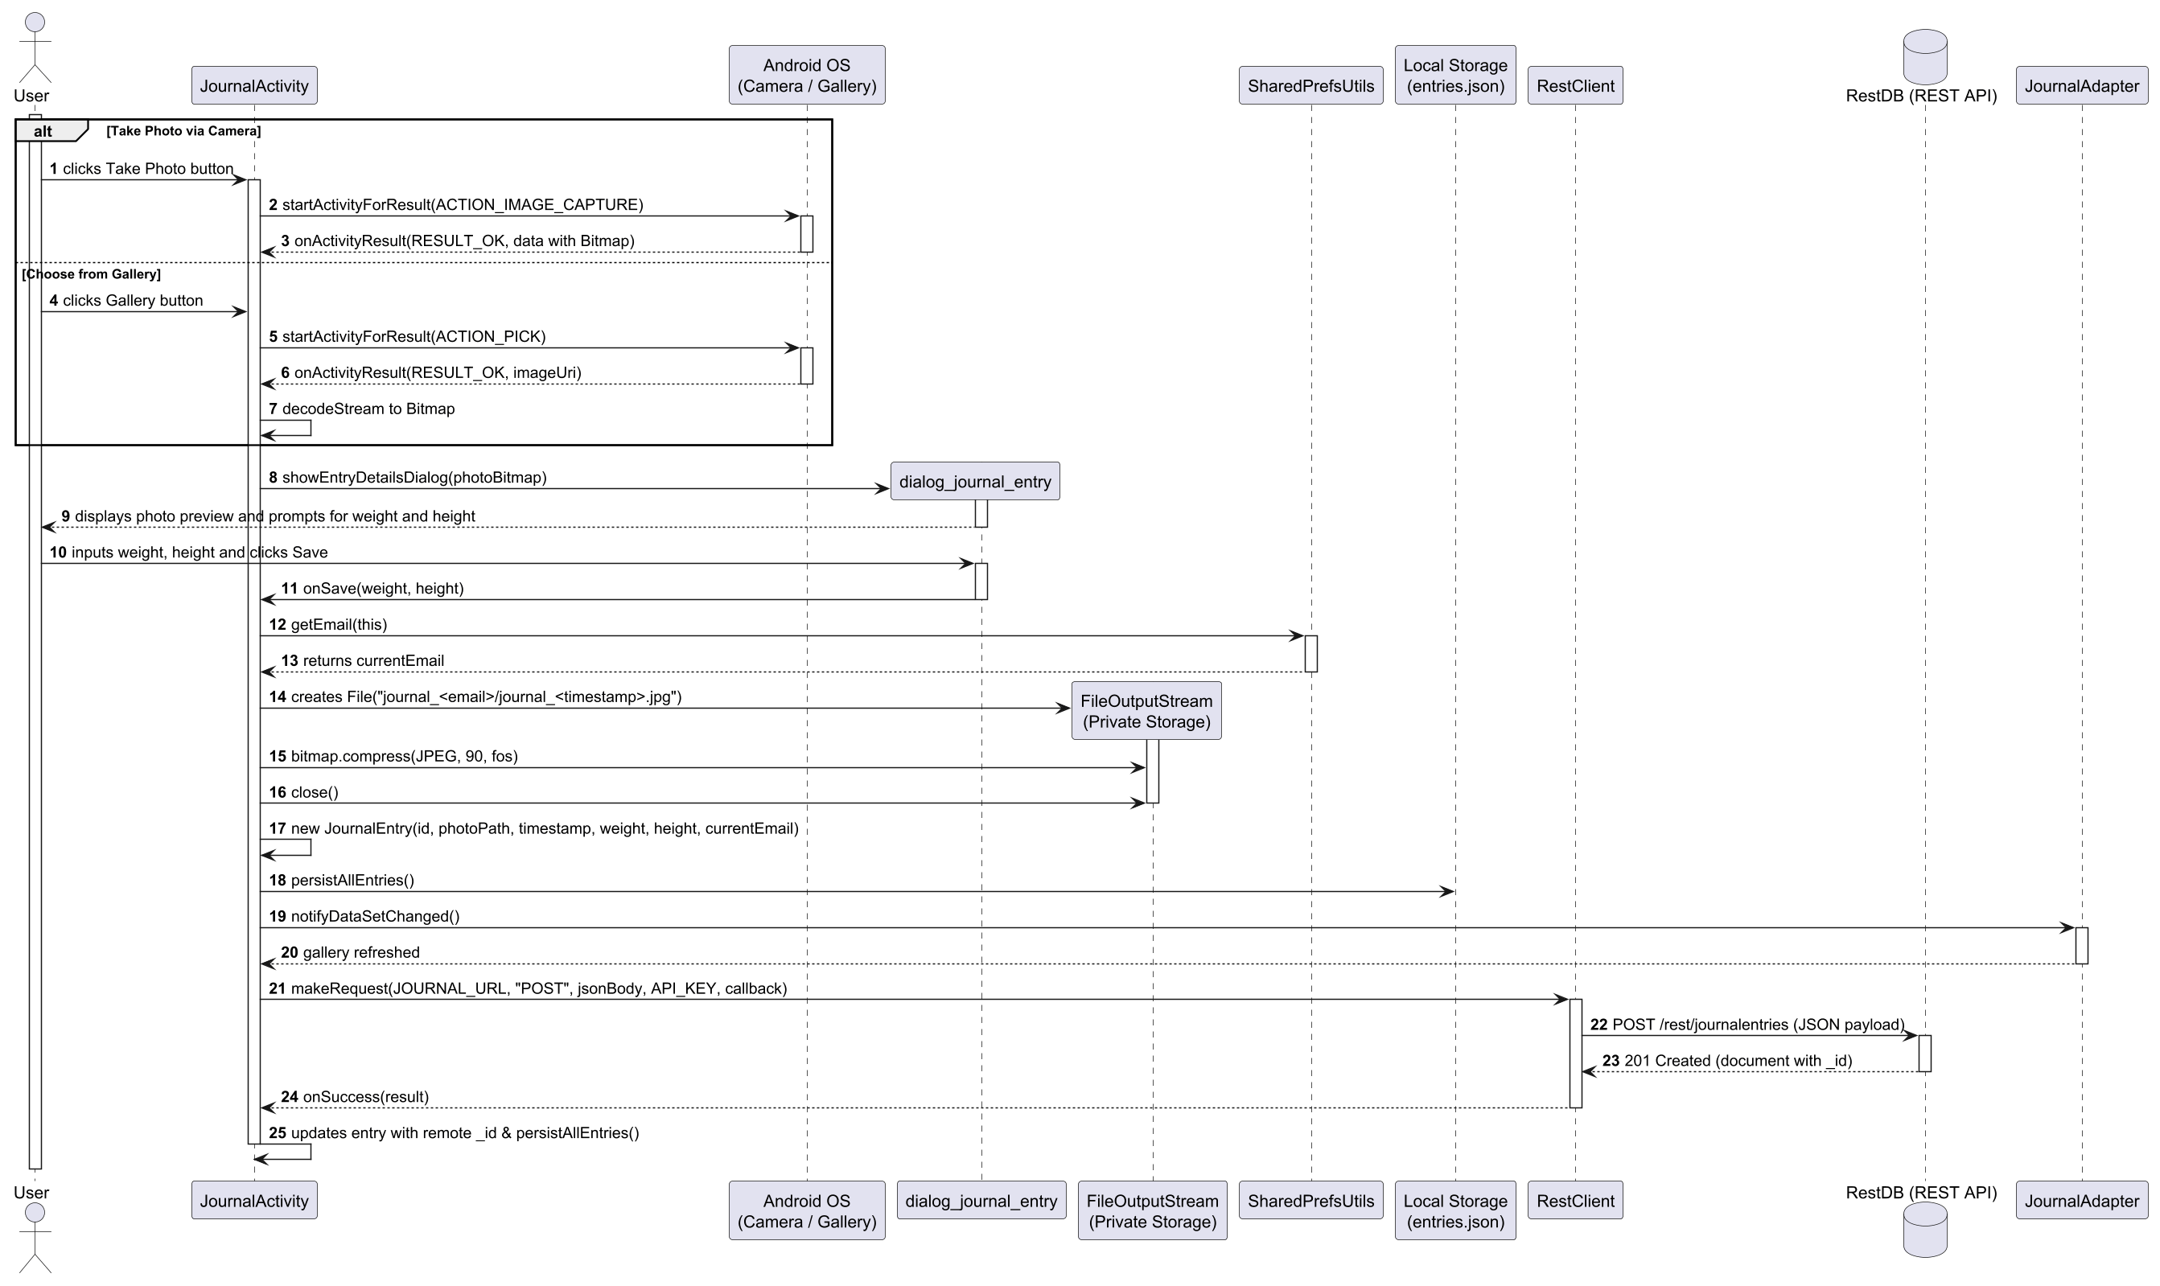
Figure 23

SDD – UC11: Delete Entry from Journal

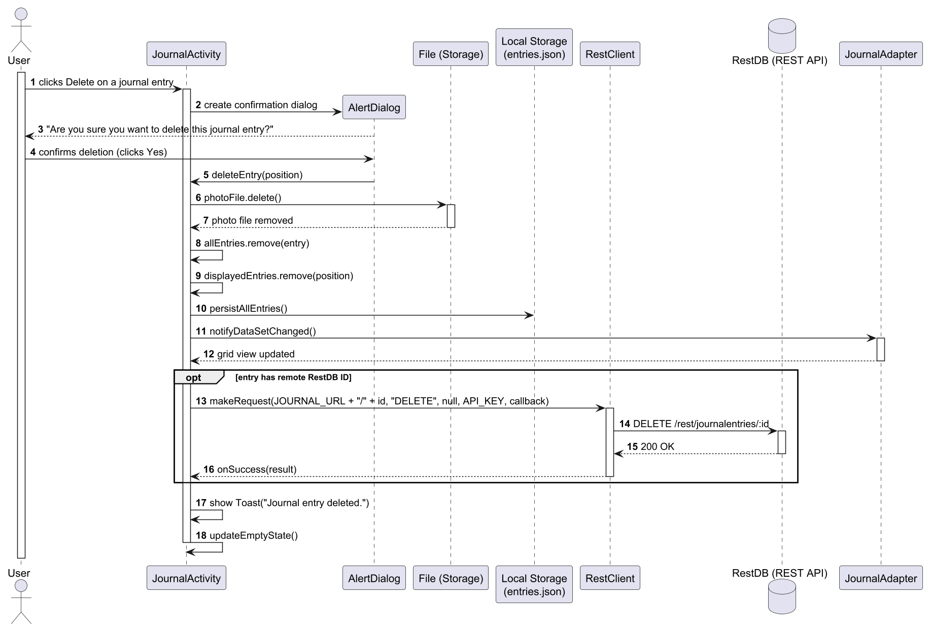
Figure 24

